White Spirit – high FBP
Properties | Unit | Specification | Test Method
Color | Saybolt | 24 | ASTM D 156
Flash Point | vol% | 45 | ASTM D 93
Aromatic | Wt% | 32.20 | ASTM D 5580
Sulfur Total | g/cm³ | 0.0828 | ASTM D 4294
Density @ 15 °C | °C | 0.795 | ASTM D 1298
IBP | °C | 155 | ASTM D 86
10% Evaporated | °C | 162
20% Evaporated | °C | 165
30% Evaporated | °C | 168
40% Evaporated | °C | 171
50% Evaporated | °C | 174
60% Evaporated | °C | 179
70% Evaporated | °C | 183
80% Evaporated | °C | 193
90% Evaporated | °C | 209
95% Evaporated | 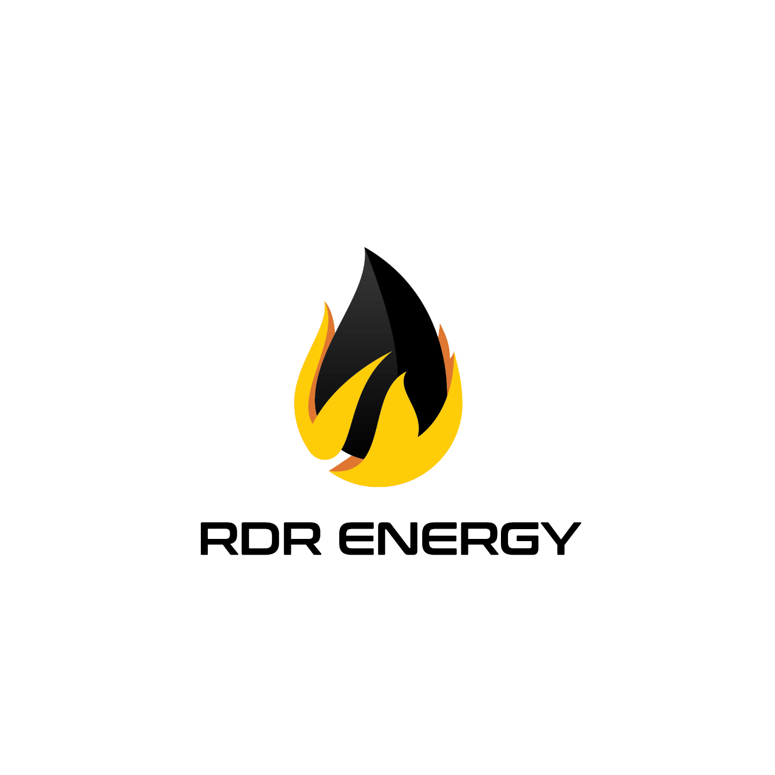  °C | 223
100% Evaporated | °C | -
FBP | °C | 245
Cetane | - | - | ASTM D 976

